10.101: a)

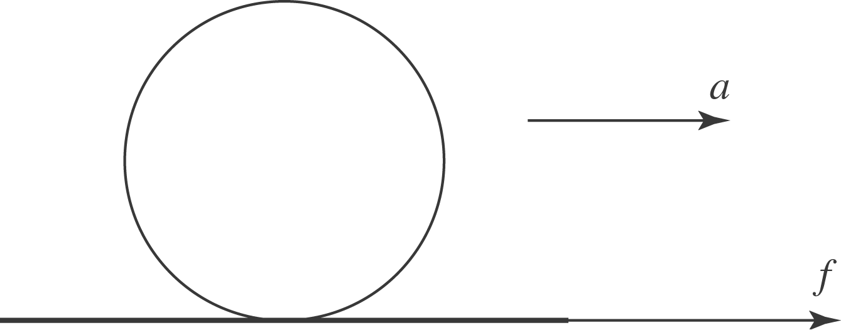
The friction force is 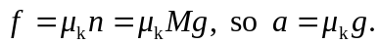 The magnitude of the angular acceleration is 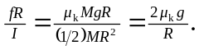 b) Setting 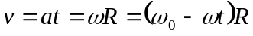 and solving for t gives

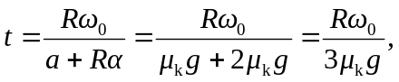
and

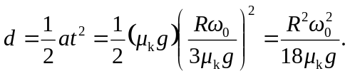

c) The final kinetic energy is 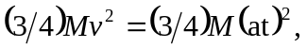so the change in kinetic energy is
